**MINI-PROJECT REPORT**

**ON**

Online Bus Ticket Reservation System



REPORT SUBMITTED

TO

VISHWAKARMA INSTITUTE OF INFORMATION TECHNOLOGY, PUNE

FOR THE PBL OF JAVA

IN

**INFORMATION TECHNOLOGY DEPARTMENT**

BY

**Name of the student –ANKUSH PATIL-21810232/232043**

**Name of the student –ABHISHEK SALAPE-21810258/232055**

**Name of the student –TEJAS SARNAIK-21810308/232056**

**Name of the student –MANASI PURKAR-21810414/232050**

**Class:SY-IT Division: B Batch:B2**

**Batch Teacher**

**Mrs.Suvarna Pawar**Online Bus Ticket Reservation System

## Abstract

Traveling is a large growing business across all countries. Bus reservation system deals with maintenance of records of details of each passenger. It also includes maintenance of information like schedule and details of each bus.

We observed the working of the Bus reservation system and after going through it, we get to know that there are many operations, which they have to do manually. It takes a lot of time and causing many errors while data entry. Due to this, sometimes a lot of problems occur and they were facing many disputes with customers. To solve the above problem, and further maintaining records of passenger details, seat availability, price per seat, bill generation and other things, we are offering this proposal of computerized reservation system.

The project provides and checks all sorts of constraints so that user does give only useful data and thus validation is done in an effective way.

## **INTRODUCTION :**

Online Bus Ticket Reservation System is a application that works within a centralized network. This project presents a review on the software program “Online Bus Ticket Reservation System” as should be used in a bus transportation system, a facility which is used to reserve seats, cancellation of reservation and different types of route enquiries used on securing quick reservations. It maintains all customer details, bus details, reservation details.

The focus of the project is to computerize traveling company to manage data, so that all the transactions become fast and there should not be any error in transaction like calculation mistake, bill generation and other things. It replaces all the paper work. It keeps records of all bills also, giving to ensure 100% successful implementation of the computerized Bus reservation system.As the database is hosted using Oracle Server onto internet, the application can access data from any part of the world, by many number of people concurrently.

## SYSTEM DESIGN

List of Entities:

1. Destination

2. Passangers

3.Billing

4. View

5. EXIT

List of attributes:

1. Fare
2. Destination
3. Special discount for old peoples and PWD

* Reserve information:

1. Passenger Name
2. Seat No

#### SYSTEM OUTPUT :

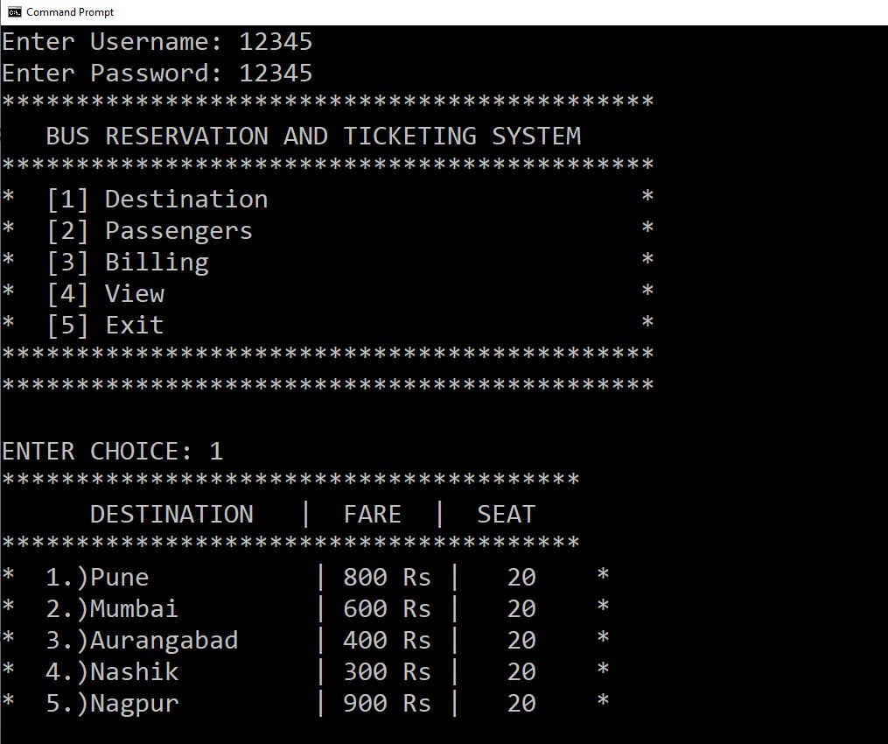

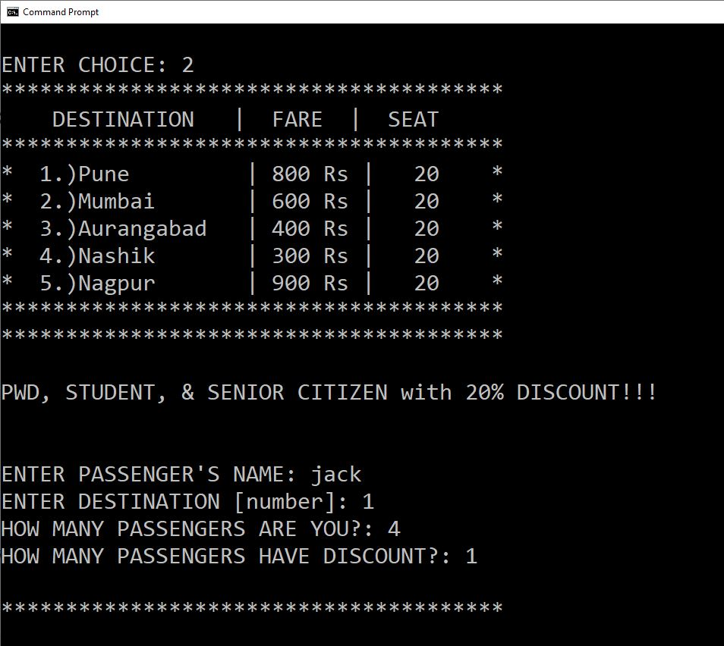

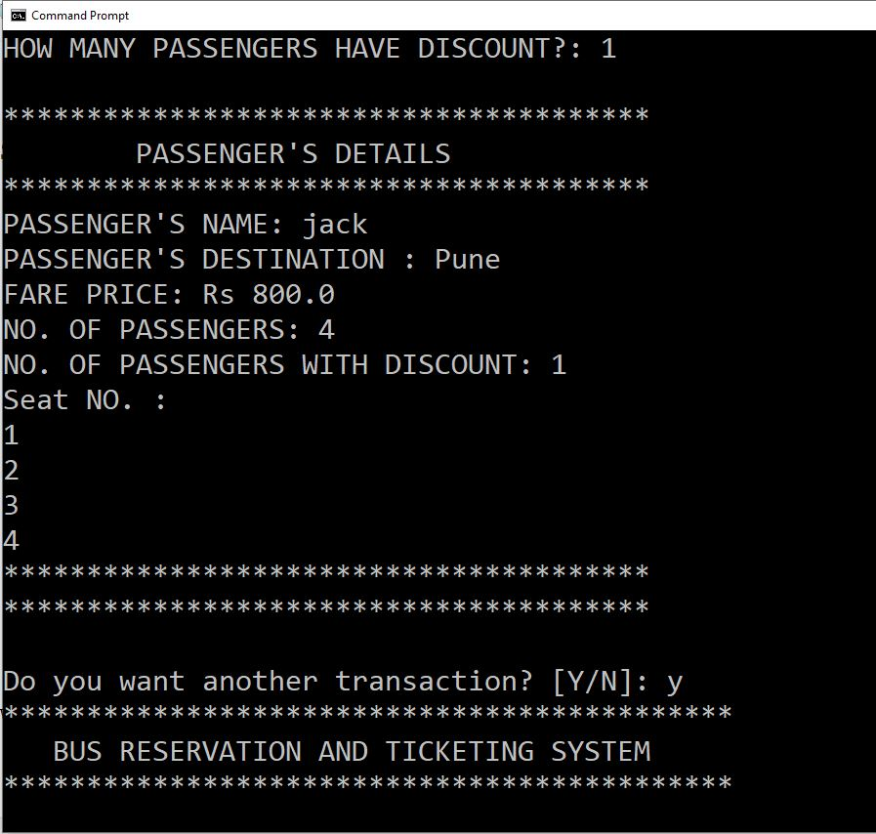

## Advantages:

a) It reduces the burden of the administrator to maintain numerous data of passengers.

b) It reduces wastage of time as it is fast and simple.

c) It is low cost.

d) Improves the efficiency of the organization.

## **CONLUSION :**

This facility is helpful for the users and the organization as well. This is a simple yet effective technology which helps the users to access the service concurrently from different places.